TEST AND CALIBRATION

Valve System Test Centre

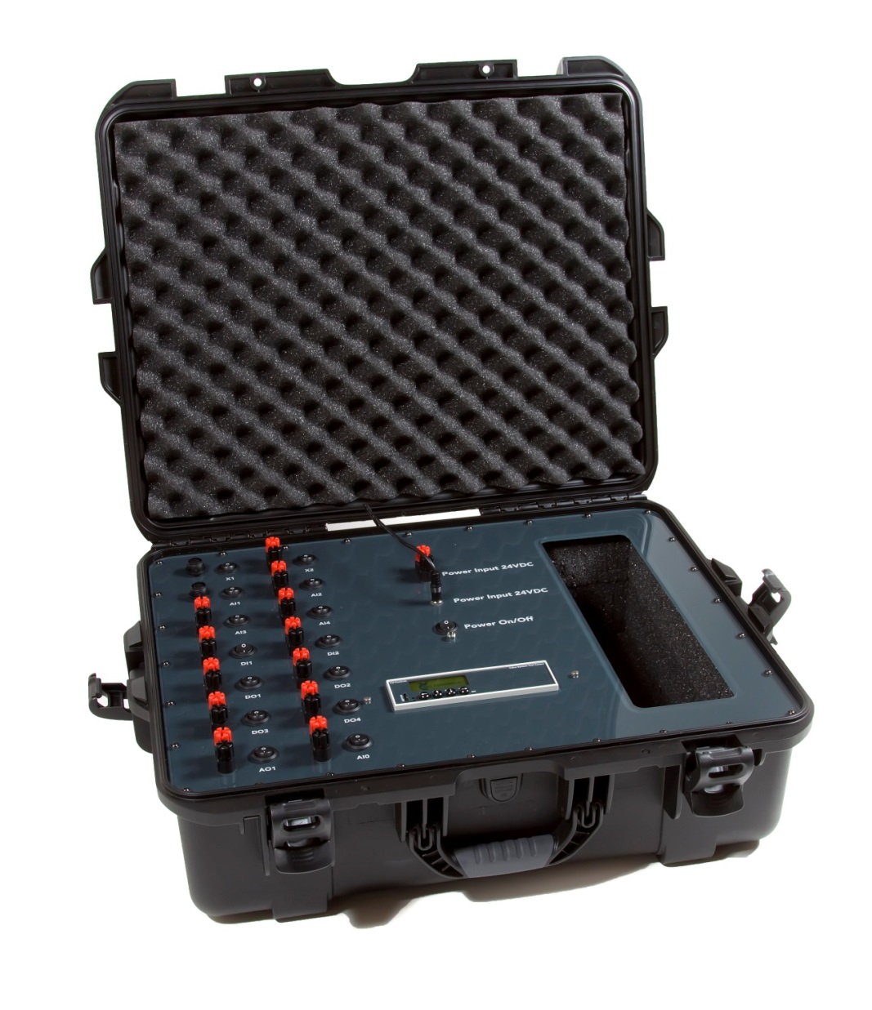

Table of contents

1 General 3
1.1 Safety instructions 3
2 Purpose 4
3 Test instruments 5
4 Test Voltage Input 6
5 Test Analogue Inputs 7
6 Test Analogue Outputs 9
7 Test Digital Inputs 10
8 Test Digital Outputs 11
9 Calibration of Analogue Inputs 12
10 Calibration of Analogue Outputs 13

General
This manual covers software version:

Software ID: DTC-SW-002
Software Version: 1.01

Safety instructions
For a safe installation of a device, the following must be observed. The module must only be installed by qualified personnel who are familiar with the national and international laws,
directives and standards that apply to this product as well as all instructions in this manual.

The information in this user manual is subject to changes without notice.

Purpose
It is the purpose of this document, to guide the user through how to test and if necessary re-calibrate the Valve System Test Centre.

Test instruments
Instruments needed for the test:
- 4-20mA Loop Calibrator
- Voltmeter
- A simple wire for short-circuit of the Digital Inputs

Calibrate Instrument
Instrument Name | Last Calibrate Date | Ref

Tested by:

Date:

Approved by:

Date:

Test Voltage Input
Input 24V power supply terminals to be tested:

- Power Supply 24VDC

Power supply test - Test
Test Signal from Calibrator | Value measured with voltmeter | Expected Result | Approved
Power supply Voltage | Result: V | 23.00V – 25.00V | ☐

Test Analogue Inputs
Input 4-20mA ports to be tested:
- AI0, AI1, AI2, AI3, AI4
- Calibrator Instrument should be configured as Passive and Source.

The inputs can be measured in the VSTC menu
- Press Status Live Status AI0 .. AI4

AI0 - Test
Test Signal from Calibrator | Value measured in VSTC Live Status menu | Tolerance 0.1% | Approved
AI0 – Test Current 4.00mA | Result: mA | 3.98 – 4.02 mA | ☐
AI0 – Test Current 8.00mA | Result: mA | 7.98 – 8.02 mA | ☐
AI0 – Test Current 12.00mA | Result: mA | 11.98 – 12.02 mA | ☐
AI0 – Test Current 16.00mA | Result: mA | 15.98 – 16.02 mA | ☐
AI0 – Test Current 20.00mA | Result: mA | 19.98 – 20.02 mA | ☐

AI1 – Test
Test Signal from Calibrator | Value measured in VSTC Live Status menu | Tolerance 0.1% | Approved
AI1 – Test Current 4.00mA | Result: mA | 3.98 – 4.02 mA | ☐
AI1 – Test Current 8.00mA | Result: mA | 7.98 – 8.02 mA | ☐
AI1 – Test Current 12.00mA | Result: mA | 11.98 – 12.02 mA | ☐
AI1 – Test Current 16.00mA | Result: mA | 15.98 – 16.02 mA | ☐
AI1 – Test Current 20.00mA | Result: mA | 19.98 – 20.02 mA | ☐

AI2 – Test
Test Signal from Calibrator | Value measured in VSTC Live Status menu | Tolerance 0.1% | Approved
AI2 – Test Current 4.00mA | Result: mA | 3.98 – 4.02 mA | ☐
AI2 – Test Current 8.00mA | Result: mA | 7.98 – 8.02 mA | ☐
AI2 – Test Current 12.00mA | Result: mA | 11.98 – 12.02 mA | ☐
AI2 – Test Current 16.00mA | Result: mA | 15.98 – 16.02 mA | ☐
AI2 – Test Current 20.00mA | Result: mA | 19.98 – 20.02 mA | ☐

AI3 - Test
Test Signal from Calibrator | Value measured in VSTC Live Status menu | Tolerance 0.1% | Approved
AI3 – Test Current 4.00mA | Result: mA | 3.98 – 4.02 mA | ☐
AI3 – Test Current 8.00mA | Result: mA | 7.98 – 8.02 mA | ☐
AI3 – Test Current 12.00mA | Result: mA | 11.98 – 12.02 mA | ☐
AI3 – Test Current 16.00mA | Result: mA | 15.98 – 16.02 mA | ☐
AI3 – Test Current 20.00mA | Result: mA | 19.98 – 20.02 mA | ☐

AI4 - Test
Test Signal from Calibrator | Value measured in VSTC Live Status menu | Tolerance 0.1% | Approved
AI4 – Test Current 4.00mA | Result: mA | 3.98 – 4.02 mA | ☐
AI4 – Test Current 8.00mA | Result: mA | 7.98 – 8.02 mA | ☐
AI4 – Test Current 12.00mA | Result: mA | 11.98 – 12.02 mA | ☐
AI4 – Test Current 16.00mA | Result: mA | 15.98 – 16.02 mA | ☐
AI4 – Test Current 20.00mA | Result: mA | 19.98 – 20.02 mA | ☐

Test Analogue Outputs
Output 4-20mA ports to be tested:
- AO1, AO2
- Calibrator Instrument should be configured as Passive and Measure.

The outputs can be controlled in the VSTC menu
- Press Menu Advanced Signal Test AO1 .. AO2

AO1 - Test
Port set in VSTC menu | Value measured on Calibrator | Tolerance 0.1% | Approved
AO1 – Output set to 4.00mA | Result: mA | 3.98 – 4.02 | ☐
AO1 – Output set to 8.00mA | Result: mA | 7.98 – 8.02 | ☐
AO1 – Output set to 12.00mA | Result: mA | 11.98 – 12.02 | ☐
AO1 – Output set to 16.00mA | Result: mA | 15.98 – 16.02 | ☐
AO1 – Output set to 20.00mA | Result: mA | 19.98 – 20.02 | ☐

AO2 - Test
Port set in VSTC menu | Value measured on Calibrator | Tolerance 0.1% | Approved
AO2 – Output set to 4.00mA | Result: mA | 3.98 – 4.02 | ☐
AO2 – Output set to 8.00mA | Result: mA | 7.98 – 8.02 | ☐
AO2 – Output set to 12.00mA | Result: mA | 11.98 – 12.02 | ☐
AO2 – Output set to 16.00mA | Result: mA | 15.98 – 16.02 | ☐
AO2 – Output set to 20.00mA | Result: mA | 19.98 – 20.02 | ☐

Test Digital Inputs
Digital Input ports to be tested:
- DI1, DI2, DI3, DI4, DI5, DI6
- Test is done by short circuit the port terminals with a simple wire.

The inputs can be measured in the VSTC menu
- Press Status Live Status DI1 .. DI6

DI1 - Test
Test Signal | Value measured in VSTC menu | Expected | Approved
DI1 – Not short circuit | Result: | Off | ☐
DI1 – Short circuit | Result: | On | ☐

DI2 - Test
Test Signal | Value measured in VSTC menu | Expected | Approved
DI2 – Not short circuit | Result: | Off | ☐
DI2 – Short circuit | Result: | On | ☐

DI3 - Test
Test Signal | Value measured in VSTC menu | Expected | Approved
DI3 – Not short circuit | Result: | Off | ☐
DI3 – Short circuit | Result: | On | ☐

DI4 - Test
Test Signal | Value measured in VSTC menu | Expected | Approved
DI4 – Not short circuit | Result: | Off | ☐
DI4 – Short circuit | Result: | On | ☐

DI5- Test
Test Signal | Value measured in VSTC menu | Expected | Approved
DI5 – Not short circuit | Result: | Off | ☐
DI5 – Short circuit | Result: | On | ☐

DI6 - Test
Test Signal | Value measured in VSTC menu | Expected | Approved
DI6 – Not short circuit | Result: | Off | ☐
DI6 – Short circuit | Result: | On | ☐

Test Digital Outputs
Digital Outputs ports to be tested:
- DO1, DO2, DO3, DO4
- There is no load on the port.
- The port is turned on and off from the VSTC pc-app

The outputs can be controlled in the VSTC menu
- Press Menu Advanced Signal Test DO1 .. DO4 On/Off

DO1 - Test
Port set in VSTC menu | Voltage measured | Expected | Approved
DO1 – Off ( without load) | Result: V | 0.00 – 10.30V | ☐
DO1 – On | Result: V | 23.00 – 25.00V | ☐

DO2 - Test
Port set in VSTC menu | Voltage measured | Expected | Approved
DO2 – Off (without load) | Result: V | 0.00 – 10.30V | ☐
DO2 – On | Result: V | 23.00 – 25.00V | ☐

DO3 - Test
Port set in VSTC menu | Voltage measured | Expected | Approved
DO3 – Off (without load) | Result: V | 0.00 – 10.30V | ☐
DO3 – On | Result: V | 23.00 – 25.00V | ☐

DO4 - Test
Port set in VSTC menu | Voltage measured | Expected | Approved
DO4 – Off (without load) | Result: V | 0.00 – 10.30V | ☐
DO4 – On | Result: V | 23.00 – 25.00V | ☐

Calibration of Analogue Inputs
If the, test failed, and the value is outside the tolerance of 0.1%, the analogue inputs can be calibrated.

This is done in the menu:
Press Menu Advanced Signal Calibration AI0 loop … AI4 loop
- Set 4mA on the connected loop calibrator, and Press [Menu] button.
- Set 20mA on the connected loop calibrator, and Press [Menu] button.

Calibration of Analogue Outputs
If the, test failed, and the values are outside the tolerance of 0.1%, the analogue outputs can be calibrated.

This is done in the menu:
Press Menu Advanced Signal Calibration AO1 loop … AO2 loop

- Tune 4.0mA with [Up], [Down] buttons until the loop calibrator shows 4.00mA, and press [Menu] button.

- Tune 20.0mA with [Up], [Down] buttons until the loop calibrator shows 20.00mA, and press Menu button.

